Now integration is basically all set!

What I would need to do is to tune some of the high level parameters to make the model more robust.

**Current problem 1:**

Scrap supply outgrows scrap demand too much, so SP2 remains at a high constant level for a long time. **Scrap supply** is not function of price. Just function of flow. It does not adjust with price. **Scrap demand** is, and it consists of 1) direct melt scrap (function of flow)

New scrap = 10.7%~11.2% end use

Old scrap = function of last hundred years flow

Direct melt scrap = 22.0%~23.4% end use

Refined scrap = ref sec production/0.99, function of TCRC and, SP2 and capacity growth

But in none of these, scrap demand will grow like scrap supply!

Ways to solve this problem:

1. Scrap demand more responsive to scrap supply, like change in sec ratio elasticity (**no solid ground**)
2. Scrap supply grows slower (change in collection rate, change in home scrap ratio, change in lifetime distribution)
3. Smaller sp2 elasticity

Tuning params:

1. Opening subsample param, 2 choices
2. Sp2 sd elasticity, original or lower
3. Home scrap and exchange scrap ratio, 2 choices

Already tried:

1. **opening high, low Sp2, high home scrap ratio**
2. **opening low, low sp2, high home scrap ratio**

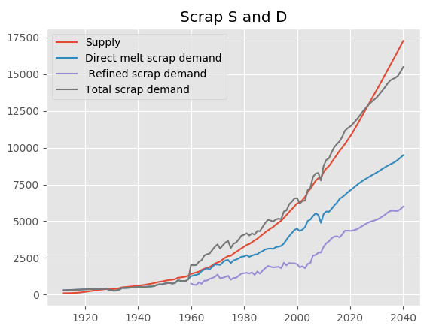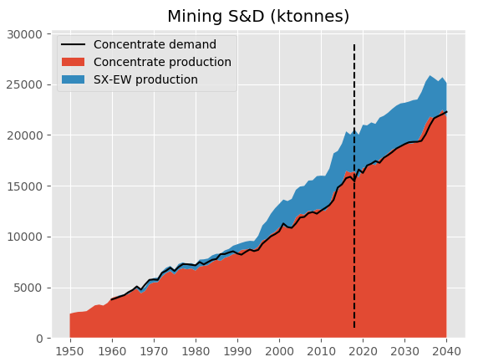

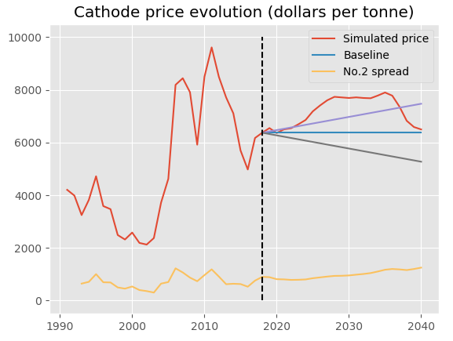

Opening low leads to price going up.